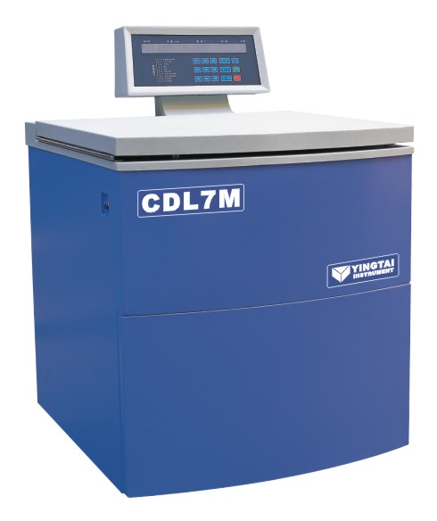

CDL7M超大容量冷冻离心机特点：
Model: CDL7M series super capacity refrigerated centrifuge
Application: widely used in the field of blood station、pharmaceutical factory、biochemistry、biological products and so on. Its max volume is 12 liter. it is the ideal instrument for blood separation、protein precipitation and cell collection.
Features:
Brushless frequency motor which in great torque, free maintenance, no powder pollution, quick in speed up and down.
The flexible axle driven system which drive the rotor directly, smooth in operation, low noise and small vibration.
Import compressors fluorine free, double cycle cooling, cold and hot alternating easily, free environment pollution and precise in temperature control.
There are more than 20 kinds of rotors for your choice
Micro computer control system, digital display the temperature、time and speed. There are 10 kinds of program and 10 kinds of acceleration and deceleration for your choice.
Automatically electric lid lock, super speed、over temperature protection and imbalance protection.
The centrifuge body is made of high-quality steel, safe and reliable.

仪器特点：
。采用无碳刷大力矩变频电机，免维护，无粉尘污染，升降速快。
。采用柔性轴驱动系统直接传动转头，运行平稳，振动小，噪音低。
。进口无氟压缩机组，双循环制冷，冷热交换能力强，无环境污染，控温精准。
。采用微机处理器精确控制转速、温度、时间，数字显示，10种程序储存，10种升降速率选用。
。门盖独立电机伺服，减轻操作人员劳动强度，超速、超温自动保护，不平衡保护，机身采用优质钢材结构；安全可靠，使用倍感方便。
。三级减振，离心效果达到最佳。

技术参数：
最高转速max speed： | 7000r/min | 最大离心力max RCF：： | 11900×g
最大容量max volume： | 6×2000ml | 温控范围temperature range： | -20°C～40°C
定时范围timer | 1～99h/59min | 噪 音noise： | ≤65dBA
外型尺寸： | 950×870×1300 | 净 重net weight： | 380 KG
控速精度： | ±50r/min | 电 源power supply ： | AC 220V 50HZ 35A
温控精度： | ±1 °C

CDL7M/CDL7MC适配转子
编号 | 转子类型 | 最高转速r/min | 容量ml | 最大离心力×g
No30324 | 角转子 | 7000 | 6×1000ml | 11900
No30399 | 水平式转子 | 4000 | 6×2000ml | 5600

